Directions and Maps

Harvard Mathematics Department
Harvard Mathematics Department is located in The Science Center Building on Harvard Yard. Harvard Yard is adjacent to Harvard Square on Mass. Avenue in Cambridge, Massachusetts.
Address:
Mathematics Department
One Oxford Street
Cambridge, MA 02138.
Tel: (617) 495-2171
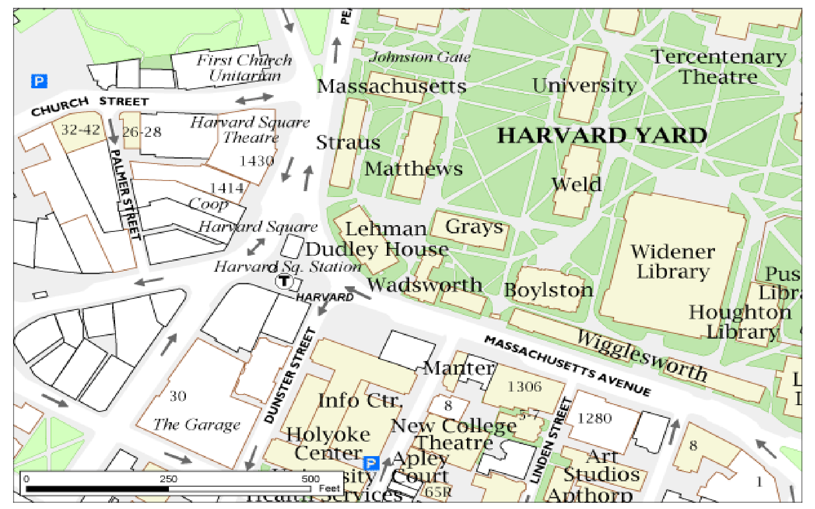

How to get to Harvard Square from Logan International Airport:

Traveling by Taxi:
Taxi services are available from Logan Airport. Taxi fare from Logan Airport to Harvard Square is $28.55.
Traveling by Subway or Bus:
Harvard MBTA Station is a station on the Red Line subway in Harvard Square. By subway (the "T"): Take the SILVER Line to South Station. Switch to the RED LINE INBOUND (toward ALEWIFE), go six stops and get off at HARVARD. The subway ride from Logan Airport takes approximately 45 minutes. The fare is $2.00.
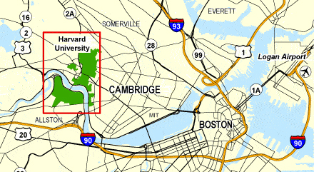

How to get to Irving House from Logan International Airport:
Address: Irving House, 24 Irving St., Cambridge, MA
Phone: (617) 547-4600
By Subway:
Take S1 Silver Line from terminal to South Station. Take the Red Line from South Station INBOUND (towards Alewife), exit at Harvard Station. Then cross Harvard yard, go to Cambridge St. and two block walk, right turn to Irving St.

How to get to The Charles Hotel from Logan International Airport:

Address: Charles Hotel, Harvard Square, One Bennett Street, Cambridge, MA 02138
Phone: (617) 864- 1200
* Departing Logan Airport, follow signs for Route 90 (Mass Pike) West.
* Take Route 90 (Mass Pike) to Exit 20 (Brighton/Cambridge).
* Bear right after the tollbooth and follow the sign for Cambridge.
* At the bottom of the ramp, turn left at the second traffic light onto Soldiers Field Road. This is just before the Charles River and there is no street sign.
* Follow Soldiers Field Road approximately 1/2 mile and take the “Harvard Square” exit.
* Turn right off of the exit ramp and proceed over the bridge.
* Continue straight across Memorial Drive past the first light onto J.F.Kennedy Street and turn left at the second light onto Eliot Street. Bear left at the next intersection onto Bennett Street and The Charles Hotel is immediately on your left.

By Subway:

Take S1 Silver Line from terminal to South Station. Take the Red Line from South Station INBOUND (towards Alewife), exit at Harvard Station. Then walk to J.F. Kennedy Street, then to Eliot Street and finally Bennett Street.

How to get to Cambridge Gateway Inn from Logan Airport:
Address: Cambridge Gateway Inn, 211 Concord Turnpike, Cambridge, MA 02140
Phone: (617) 661-7800

By Car:

* Go through the Sumner Tunnel to I-93 North.
* Take Exit 31 (Mystic Valley Parkway, Route 16 West).
* Travel Route 16 West for 3.5 miles.
* Take right onto Route 2 West.
* Hotel will be on the left; however, the highway is divided.
* Therefore, proceed to Exit 60 (Lake Street) to reverse direction.
* Cambridge Gateway Inn will be on your right on Route 2 East.

By Subway:

Take S1 Silver Line from terminal to South Station. Take the Red Line from South Station INBOUND (towards Alewife), exit at Alewife Station.
Take the Shuttle to Gateway Inn. Shuttles go back and forth every half an hour daily, from 8am to 6pm.
You can walk ¼ mile (8 minutes) to the hotel from the Station, turn (right) to Alewife Station Access Rd on the west of the station building, the road is merged with Concord Turnpike (Road 2) after your 3 minutes walk, follow Concord Turnpike to west, you will see the hotel sign.

How to get to Sheraton Commander from Logan Airport:
Address: Sheraton Commander Hotel, 16 Garden Street, Cambridge, MA 02138
Phone: (617) 547-4800
By Car:
From Interstate 93 South, take Exit 26A to Storrow Drive West. Continue to Harvard Square, turn right and cross over the river. At the 5th set of lights, turn left, and then immediately turn right onto Garden Street. Proceed one-quarter mile to the hotel.
By Subway:
Take S1 Silver Line from terminal to South Station. Take the Red Line from South Station INBOUND (towards Alewife), exit at Harvard Station. Then walk to Garden Street.

How to get to A Friendly Inn from Logan Airport:
Address: A Friendly Inn at Harvard, 1673 Cambridge Street, Cambridge, MA 02138
Phone: (617) 547-7851
By Car:
Logan Airport - Follow the signs for Boston & Route 93 North, exit Cambridge/Storrow Drive and take Storrow Drive to Harvard Square. You can also follow the signs to Mass Pike, which is faster, but there is a $1 toll charge.
By Subway:
Take S1 Silver Line from terminal to South Station. Take the Red Line from South Station INBOUND (towards Alewife), exit at Harvard Station. Then cross Harvard yard, go to Cambridge St. and walk two blocks, you will see the Inn located on the corner with Irving St.

How to get to A Cambridge House from Logan Airport:
Address: A Cambridge House, 2218 Mass. Ave. Cambridge, MA 02140
Phone: (617) 491-6300
By subway (MBTA):
Exit Airport terminal at ground transportation and get onto the AIRPORT SHUTTLE BUS. Exit the bus at the Airport MBTA stop (Blue Line). Purchase a subway token ($1) and get on the Blue Line train Inbound. Take it four stops to Government Center where you will switch to the Green Line inbound.
Take the Green Line one stop to Park Street where you will switch to the Red Line towards Harvard/Alewife.
Take the Red Line six stops to the Davis stop. Exit on to Holland Street, turn right, walk past the Somerville Theater, take second right on Day Street (Singer Sewing on corner). Walk straight up Day Street towards traffic of Massachusetts Avenue. One at Mass. Ave., cross street. To left is A Cambridge House (yellow house).

How to get to Marriott Hotel from Logan Airport:
Address: Marriott, Two Cambridge Center, 50 Broadway, Cambridge, MA 02144
Phone: (617) 494-6600
By Car:
Depart on Service Rd. Bear Right onto Local road. Merge onto Local Road. Take Ramp onto SR-1A. Turn Right onyo Ramp. Take Ramp onto SR-28. Turn Left onto Ramp. Turn Right onto SR-3. Road name changes to Main St. Road name changes to Broadway. Turn Left onto local road.
By Subway:
Exit Airport terminal at ground transportation and get onto the AIRPORT SHUTTLE BUS. Exit the bus at the Airport MBTA stop (Blue Line). Purchase a subway token ($1) and get on the Blue Line train Inbound. Take it four stops to Government Center where you will switch to the Green Line inbound.
Take the Green Line one stop to Park Street where you will switch to the Red Line towards Harvard/Alewife direction.
Take the Red Line two stops to Kendal Station (MIT station). You will see Marriott Hotel about T station.

Banquet at Royal East Restaurant (Chinese):
Address: Royal East, 782-792 Main Street, Cambridge, MA 02139

How to get to Royal East from Harvard Square:
By walking or by car:
On Harvard Square walk up to Mount Auburn Street, then to Mass Avenue then Main Street.
By Subway from Harvard Station:
From Harvard Station take subway to Central Square, then for 13 minutes to 792 Main Street.
By Subway from Logan Airport:
S1 Silver Line South Station to Red Line-Alewife. Red Line-Alewife to Central Square. Walk for 13 minutes to 792 Main Street.

Banquet at the American Academy of Arts and Sciences.
Address: American Academy of Arts & Sciences, 136 Irving Street,
Cambridge, MA 02138
How to get to the AAAS from Harvard Science Center:
By walking or by car from Science Center:
Get to Oxford Street from Science Center Oxford entrance, turn right into Kirkland St.
Follow Kirkland Street for four blocks. Turn left onto Irving Street. Bear middle (three ways forward) at the next intersection onto Scott Street. Merge forward into Bryant St.
Turn left into Beacon Street. At the next corner is the pedestrian entrance to the Academy (200 Beacon Street).
Park and enter the Academy grounds by the gate; follow the pathway to the main entrance at 200 Beacon Street.
Please follow all parking restrictions, including "Resident permit only", as posted by Cambridge and Somerville.
By Subway from Logan Airport:
From the Airport:
Take the Blue Line inbound from Logan to Government Center, switch to the Green Line inbound for one stop, exiting at Park Street station. Or take Silver line to South Station.
Switch to the Red Line heading toward Alewife and get off at Harvard Sq Stop.
Cross Harvard yard, follow Quincy St into Kirkland St.
Follow the walking direction above (from Science Center)

If you are missed and need emergent help, please call Math Department of Harvard (617) 495-2171 or 617-495-1980 (Gena) between 9:00 AM and 5:00 PM weekdays, and Liping Huang 617-686-0848 any other time.

